Last Update: 8/18/21
This QRG outlines the Pay Change – Pay Decrease process for an employee in SuccessFactors.
Contents
What is a Pay Decrease? 1
Pay Decrease Process 1
Access SuccessFactors 2
Searching for an Employee 2
Taking Action 3
Processing a Pay Change – Pay Decrease 5

What is a Pay Decrease?
A Pay Decrease is a reduction to an employee’s salary or hourly rate. All Pay Changes must be made in accordance with University Policy, Pay Practices, and Pay Rates/Scales.

Pay Decrease Process
The Initiator processes the Pay Decrease in SuccessFactors. Once complete, HR Compensation is notified. There are no in-system approvals or workflow.

Access SuccessFactors
Visit OneCampus and select Employee Launchpad or from the Employee Self-Service web page click SuccessFactors  Log in using Purdue Career Account ID and Password. |  | https://one.purdue.edu/  https://www.purdue.edu/hr/global/pgnew.php

Searching for an Employee
- From the SuccessFactors home page, locate the Search field on the navigation bar.  - In the Search field, type the employee’s name.  - Multiple matches may be displayed.  Scroll to select the correct name, click to select. |  | 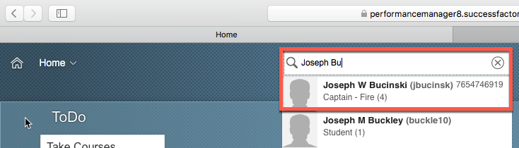
This will display the employee’s Employee File. |  | 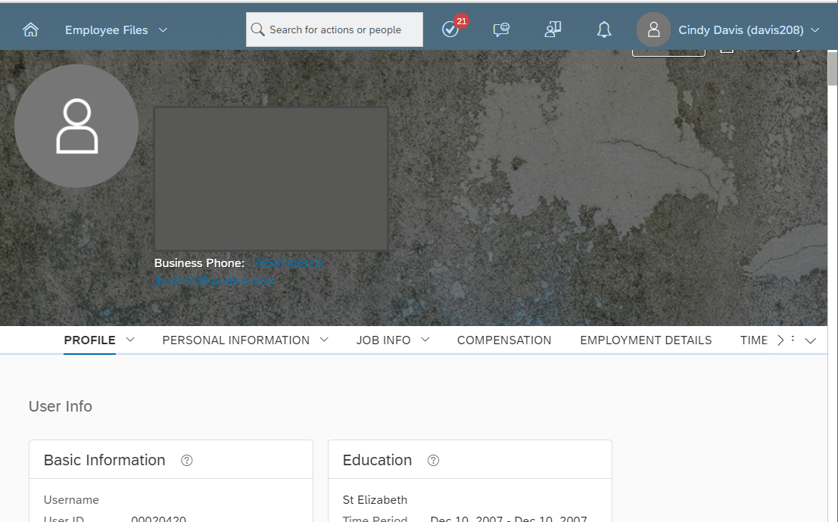

Taking Action
The first option is found on the employee’s Employee Profile.  Click Take Action to display action options.  Once the action options are displayed, select Change Job and Compensation Info to begin processing the Pay Change – Pay Decrease. |  | 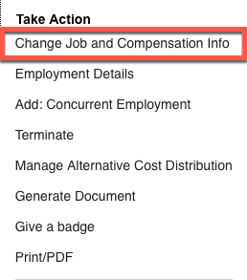
The other option is found on the SuccessFactors home page.  Once the employee has been located, hover over their name to view their employee information within a separate pop up window.  Next, click Take Action to display action options. |  | 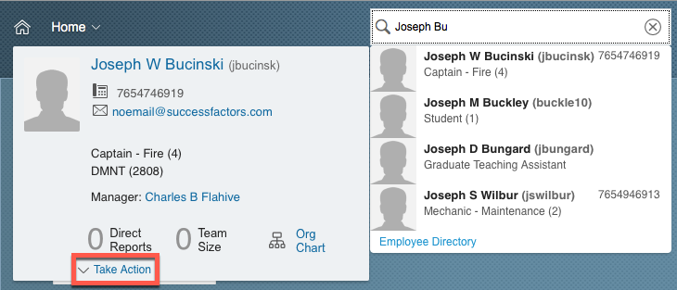
Once the action options are  displayed, select Change Job  and Compensation Info to  begin processing the Pay  Change – Pay Decrease. . |  | 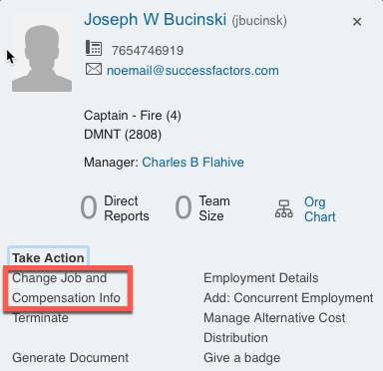

Processing a Pay Change – Pay Decrease
Click the checkbox to select Compensation Information.  Next, manually input the date (mm/dd/yy) the job change should take effect or click the Calendar icon to display a calendar.  Click the day the Pay Change – Pay Decrease change should take effect to populate the date field. |  | 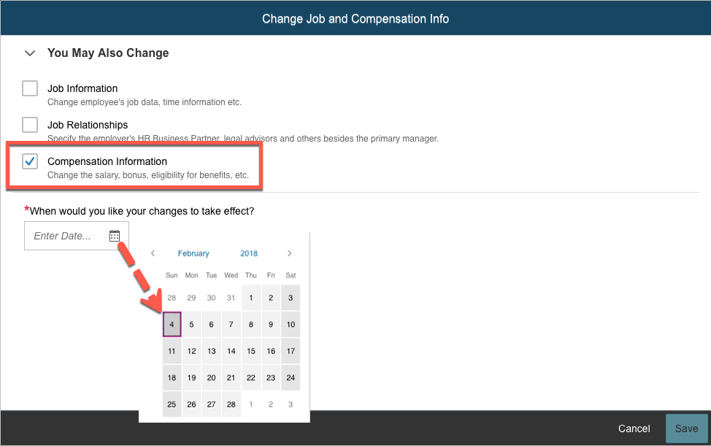
Once the date field has been populated, the field options associated with all selected change types are displayed. |  | 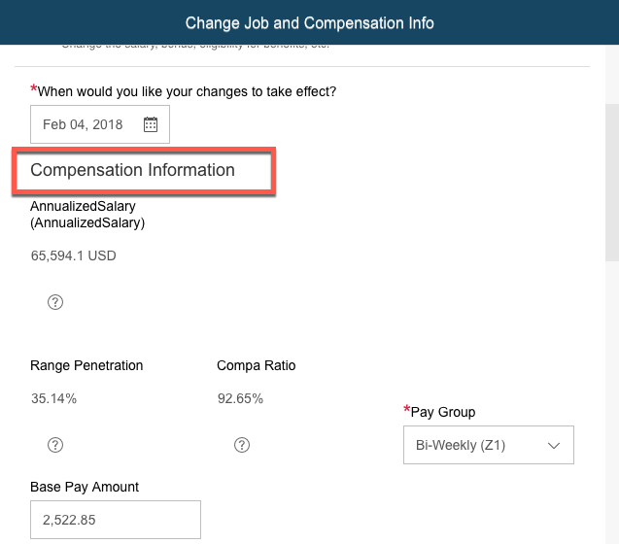
Scroll down to the Amount field under the Compensation header.
Enter the new amount in the Amount field.
Alternatively, use the calculator to change the existing amount by a specific percentage.
- Click the Calculator icon to display the Change Calculator box.
- Type either the value of the change in the Change Amount field or the percentage of the change in the Change Percent field.
- Because this is a pay decrease, place a (-) sign in front of the value.
- The Total Amount field will be auto-populated.
- Click Save on the Change Calculator box.

- Click Save on the Change Job and Compensation Info box.
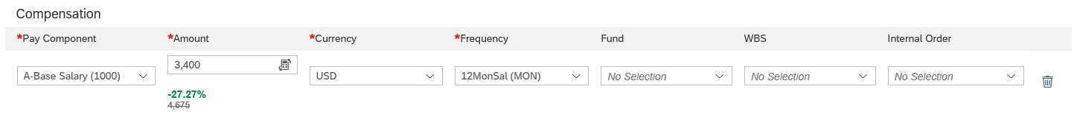
Receive notice that the changes were successfully saved. | 